Amrita Kumari 6362289
WEEK - 5 (Module - 5)
Yash Raj
SuperSet ID - (6364442)

Lab6- WebApi_Handson

Kafka Integration with C#:
Apache Kafka is a distributed event streaming platform used for high- performance data pipelines, streaming analytic, data integration, and mission-critical applications. It allows:
- Producers to send data (messages),
- Topics to categorize the data,
- Consumers to read it.

Kafka Architecture Overview
- Producer: Sends messages to a topic.
- Topic: Logical channel for messages.
- Partition: Sub-division of a topic for load balancing.
- Broker: Kafka server storing data.
- Consumer: Reads messages from topics.
- Zookeeper: Manages Kafka brokers and cluster coordination.
Starting Zookeeper:
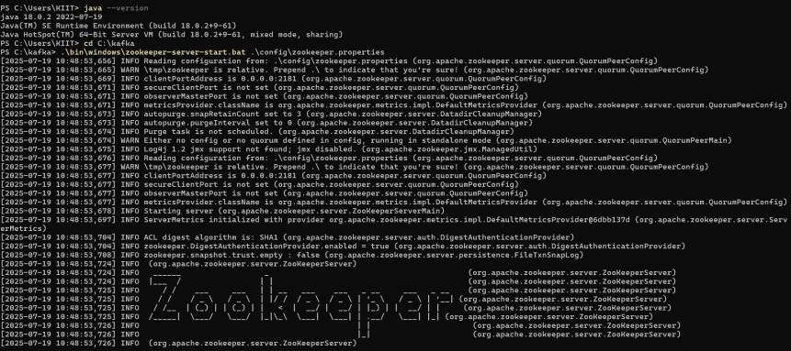
Starting Kafka Server:
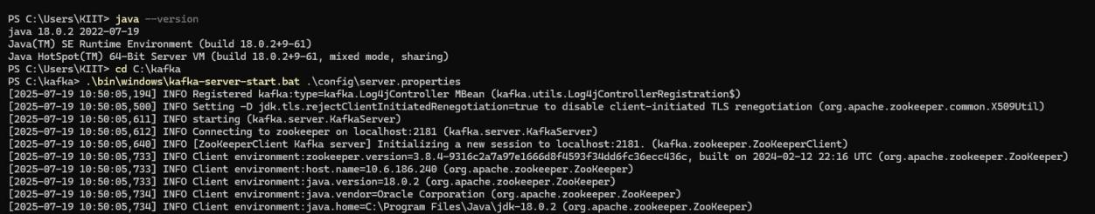
Creating a Kafka Topic:
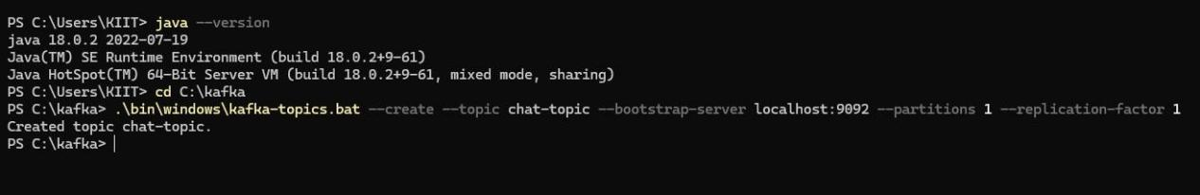

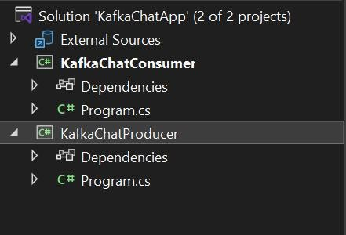
- Creating a Chat Application which uses Kafka as a streaming platform and consuming the chat messages in the command prompt’s output.
Chat in Producer
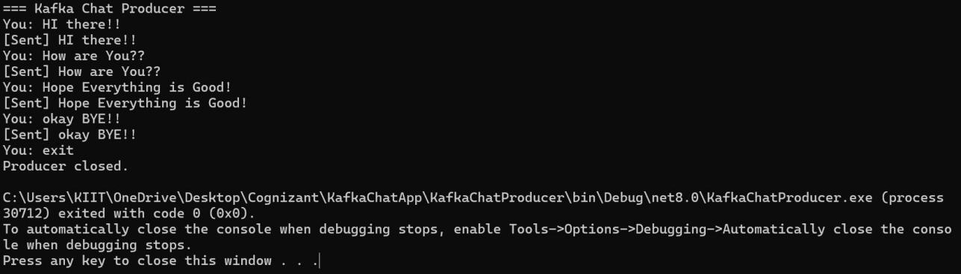
Output in Consumer
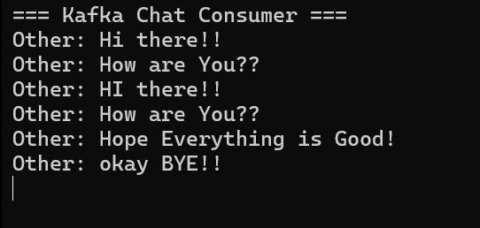

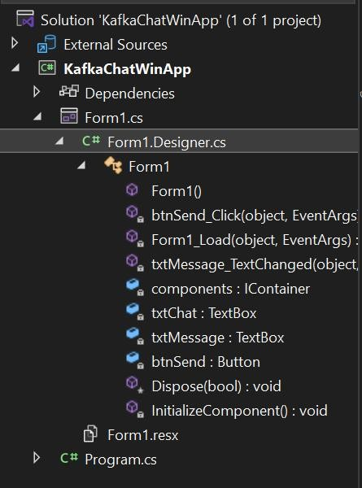

- Create a Chat Application using C# Windows Application using Kafka and consume the message in different client applications.
Chat client
